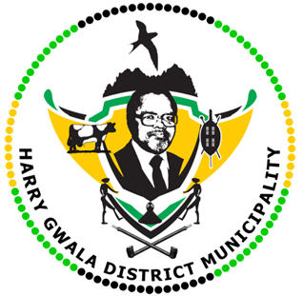
HARRY GWALA DISTRICT MUNICIPALITY
“Together We Deliver and Grow”
OFFICE OF THE MUNICIPAL MANAGER
40 Main Street, Private Bag X501, IXOPO 3276
Tel: (039) 834 8754 Fax: (039) 834 1701
Email: mbanjwas@harrygwaladm.gov.za

08 June 2022

Site Visit by Harry Gwala District Municipality leadership.

Harry Gwala District Municipality councillors led by Mayor Cllr. Zamo Nxumalo and Speaker Sibongiseni Mdunge and the district management today (08 June 2022), Visited different sites for fact finding mission. Among the sites visited includes Rectification and upgrade of Fairview and IXopo sewer phase 2&3, Ibisi housing sewer reticulation and Greater Summerfield Water supply project both in UMzimkhulu. Mayor Nxumalo engaged with project managers in these sites. Mayor Nxumalo said it was necessary that projects are manager accordingly and that municipality get updates constantly.
“We are here to make sure that everything is going according to plan and to ensure that the people of Harry Gwala District get services delivered to them especially water and sanitation,” Said Nxumalo.
Speaker and Mayor said there would keep an eye on these project and would make an unannounced visit to check on progress.

ISSUED BY HARRY GWALA DISTRICT MUNICIPALITY COMMUNICATIONS UNIT

